RC CAR – DESIGN, WORKING, SIMULATION & PCB DEVELOPMENT

1. Introduction
An RC Car (Radio Controlled Car) is a miniature vehicle operated wirelessly using a handheld transmitter. It ranges from simple toy-grade models to advanced hobby-grade and research platforms. RC cars are widely used for education, hobby projects, robotics competitions, and prototype development. They help learners understand electronics, mechanics, wireless communication, and control systems.
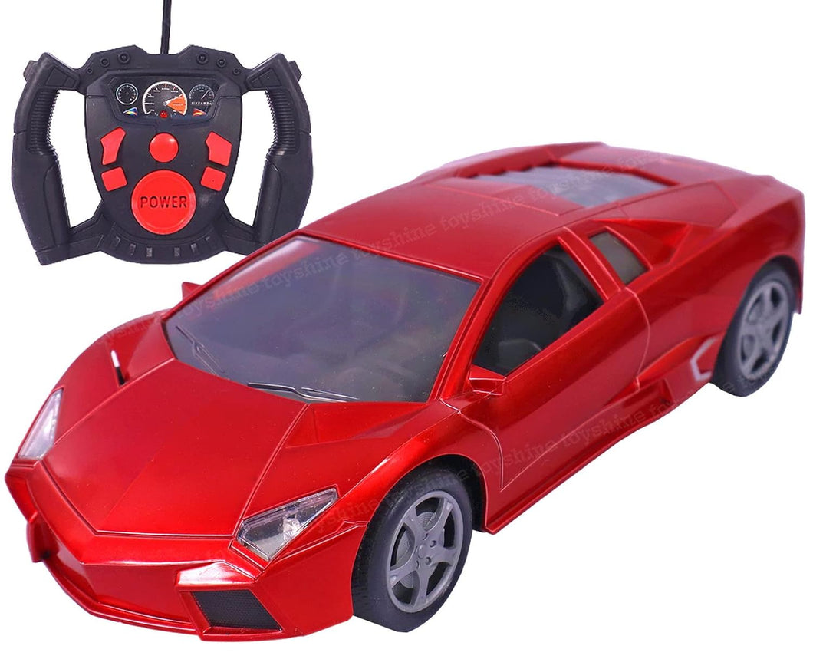

2. System Overview
An RC car system consists of:
- A remote transmitter for user input
- A receiver module inside the car
- A control motherboard / PCB
- Motor driver and motors for movement
- Servo motor for steering
- Battery and power management system

3. Block Diagram (Text Representation)
[Remote Transmitter]
↓ RF Signal
[Receiver Module]
↓ Control Signals
[Microcontroller / Motherboard]
↓ PWM Control
[Motor Driver / ESC]
↓
[DC Motor / Servo Motor]
↓
[Wheels & Steering Mechanism]

Battery → Power Distribution → All Components
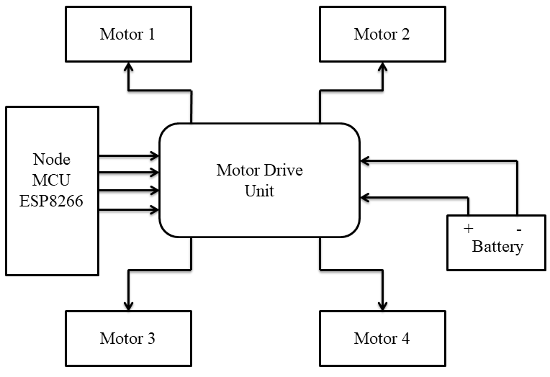

4. Main Components of RC Car

4.1 Transmitter (Remote Controller)
- Sends wireless commands to the RC car
- Controls speed, direction, and steering
- Operates on RF frequencies (commonly 2.4 GHz)

4.2 Receiver Module
- Receives signals from the transmitter
- Decodes commands and sends them to control units

4.3 Motherboard / Control PCB
- Acts as the brain of the RC car
- Performs signal processing and power distribution
- Interfaces MCU, ESC, receiver, and servo

4.4 Electronic Speed Controller (ESC) / Motor Driver
- Controls motor speed and direction
- Converts low-power control signals into high-current motor output

4.5 DC Motor / Brushless Motor
- Provides forward and backward motion
- Types:
  - Brushed DC Motor
  - Brushless DC Motor (high efficiency and durability)

4.6 Servo Motor
- Controls steering of front wheels
- Provides precise angular movement

4.7 Battery and Power System
- Supplies power to motors and electronics
- Common types:
  - NiMH
  - Li-ion
  - Li-Po

4.8 Chassis, Wheels & Suspension
- Chassis supports and protects all components
- Suspension absorbs shocks and improves stability
- Wheels provide traction based on terrain

5. Working Principle of RC Car
- User operates joystick on transmitter
- RF signal is transmitted wirelessly
- Receiver receives and decodes signal
- Microcontroller processes command
- ESC drives motor speed and direction
- Servo motor controls steering
- Car moves as per user command

6. Internal Control Flow

Signal Flow
User Input → Transmitter → Receiver → ESC → Motor → Wheels

Steering Flow
User Steering Input → Transmitter → Receiver → Servo → Front Wheels

Power Flow
Battery → Voltage Regulation → ESC / MCU / Servo

7. Types of RC Cars
- Electric RC Car – Battery powered, easy maintenance
- Nitro RC Car – Fuel powered, high realism
- Toy-grade RC Car – Integrated PCB, limited performance
- Hobby-grade RC Car – Modular, high performance

8. Tinkercad Simulation & Arduino Implementation

Simulation Overview
The RC car circuit is designed and tested in Tinkercad using:
- Arduino Uno
- L293D motor driver
- DC motor
- Analog input
This allows testing before physical implementation.

9. Arduino Program
int MPin = 9; // Motor pin
int Analog = A0; // Analog input
int Ainp = 0;

void setup()
{
Serial.begin(9600);
pinMode(MPin, OUTPUT);
pinMode(Analog, INPUT);
}

void loop()
{
Ainp = analogRead(A0);
int Speed = map(Ainp, 0, 1024, 0, 255);
delay(100);
Serial.println(Speed);
analogWrite(MPin, Speed);
}

Code Explanation
- Reads analog input
- Maps input to motor speed
- Controls motor using PWM
- Allows smooth speed control

- Wiring &pin diagram
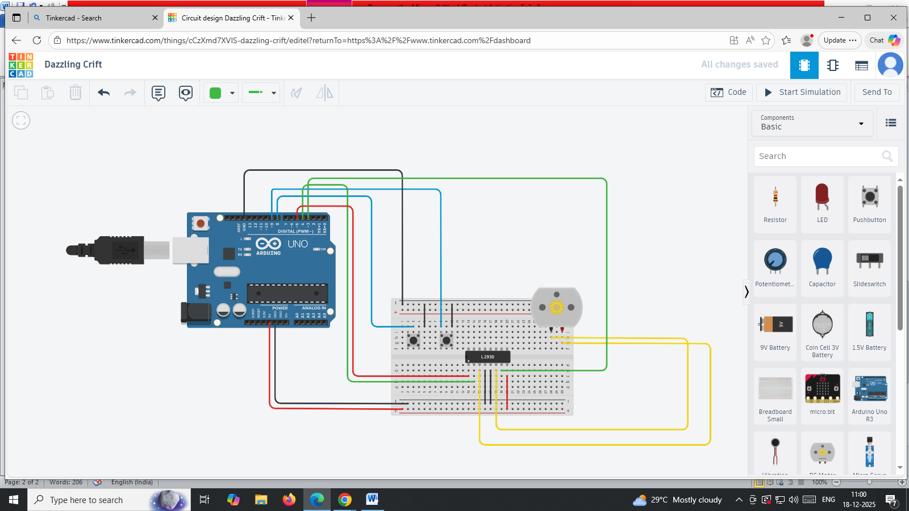

10. PCB Design for RC Car Control System

10.1 Objective
- Design a compact, reliable RC car control PCB
- Integrate MCU, motor driver, RF module, and power regulation
- Ensure safe high-current motor operation

11. PCB Functional Blocks
- Power Input & Protection
- Voltage Regulation (5V, 3.3V)
- Microcontroller Unit (MCU)
- Motor Driver (H-Bridge)
- Servo Interface
- RF Communication Module
- Programming Interface

12. PCB Layout Guidelines
- Place MCU at center of board
- Keep RF module away from motor driver
- Use wide copper traces for motor currents
- Separate logic ground and motor ground
- Maintain antenna clearance

13. PCB Manufacturing Files
- Gerber files
- Drill files
- Pick & Place file
- Assembly drawings
- Bill of Materials (BOM)

14. Applications of RC Car
- Educational electronics projects
- Robotics competitions
- Research and prototype testing
- Surveillance and military prototypes
- Autonomous vehicle experiments

15. Advantages of RC Car
- Easy wireless control
- Enhances electronics and programming skills
- Customizable and upgradeable
- Practical learning platform for STEM
- Cost-effective prototype system

16. Conclusion
The RC Car project integrates electronics, programming, mechanical design, simulation, and PCB development into a single system. It serves as an excellent learning platform for understanding wireless control systems, embedded programming, and real-world engineering applications. This project can be further extended with sensors, IoT, and autonomous features.

